A ship note... Peter Burt & Margaret Beveridge
"The Statira Morse" arriving US 15 Sept 1851. Port of New York (from Glasgow)
(the picture looks like it says 1857)
Passengers: Page 1 All references to Beverage – shd be Beveridge
 | Peter Thomson 40 | 1811 | Flax?? | Scotland
 | James Beverage 38 | 1814 | Miner | Scotland
Consensus is that this should say  Peter Burt | Andrew Burt 34 | 1818 | Miner | Scotland
 | Andrew Beverage 25 | 1827 | Miner | Scotland
Peter’s brother was b. 1826 | David Burt 25 | 1827 | Miner | Scotland
wife of James Beveridge –  should say Euphemia Beveridge | Euphemia Burt 36/31 | 1820? | Wife | Scotland
Peter’s wife  Margaret Beveridge b. 1819 | Margaret Burt 33 | 1819 | Wife | Scotland
 | Alexander Beverage 5 | 1846 |  | Scotland
Child of Peter & Margaret | Agnes Burt 9 | 1843 |  | Scotland
Child of Peter & Margaret | Isabella Burt 7 | 1845 |  | Scotland
Child of Peter & Margaret | Margaret Burt 5 | 1847 |  | Scotland
Child of Peter & Margaret  Thomas Peter Burt | Peter Burt 10/12 | 1850 |  | Scotland
Child of James and Euphemia Beveridge | James Beverage 8 mo |  |  | Scotland
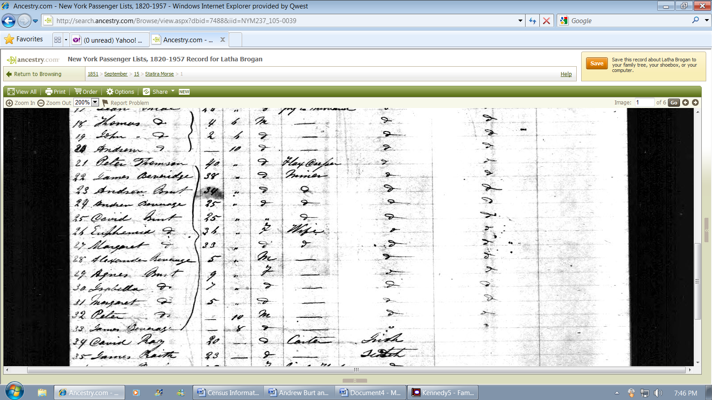

Information matches ages of Peter Burt family in 1851 Scotland Census

